IT24102566

Lab 06

Munasinghe D.D.T

1.

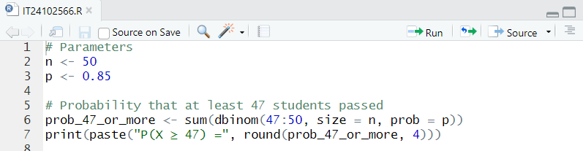

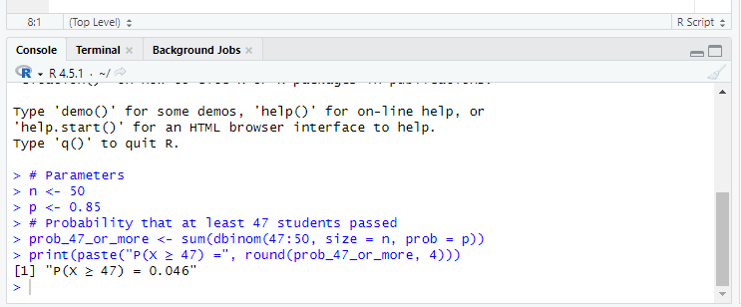

2.

